Cis 425 project proposal:

Xiaozhi Li

Type: a CAD tool

Target: a CAD tool that utilizes 3d shaped objects and can export and import files. It has multiple windows to visualize the object in creation.

Details；

There will be buttons on the side, which generates objects in the center as described.

There will have multiple objects to be chosen from, a sphere, a cylinder, a cube, a cuboid.

Each of these objects can have their dimension changed (the sphere and cylinder should have their slices and stacks changed), by clicking on them, and then presses some button.

Each of these objects can be turned around, by keyboard.

Each of these objects can be moved around, in 3d space.

There will be at least 3 windows, each looks at the scene from a different angle.

There should be a reasonable limit of the maximum objects one can have in the scene.

The objects, and the coordinates of the objects, can be exported out into a file.

Should the exported file exist, the program can read it and extract the same object file and print it to the scene.

Bonuses：(objects that I want to explore but could be out of the scope of this project)

1. Selecting multiple objects using a click and drag selecting square.
2. Press w to have a mini 3 dimension coordinate axis appear on the selecting object, each axis corelates to the world x, y, or z direction, dragging on that axis would activate moving the selected objects along that axis, then press button up to move it in positive direction, button down to move it in negative direction. Example: 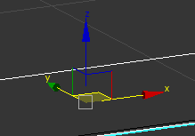
3. Press e would have 3 wired circle around the object, each works as a activator for angular rotater: 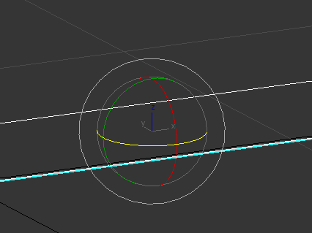
4. Press r would have 3 axis that each activates the re size of the object: 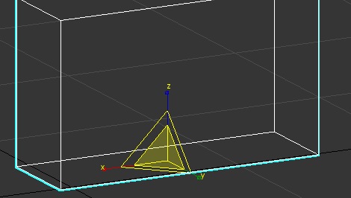
5. In 2, 3, and 4 the dimension is adjusted using keys “up” and “down”, I want to explore if it is possible to use mouse click and drag (for resize and move it is easier but for rotating mouse drag could get tricky)
6. While selecting two objects at the same time, one can press “g” to group the two objects, and then any modification on these two objects are combined.

Explanation:

The idea of making this CAD tool is inspired by my experience of using 3d studio max, my goal is to make the most basic functions of 3ds max possible using the knowledge I learned. The difficulty of this project is around how to move, rotate, resize, import and export objects as an individual and as a group while dealing with the conflicts. The strategy is to use generic design so this tool can actually be used for creating 3d objects.